J.P. Vaeth

09/24/24

Capstone Storyboard

Abstract:

A group of dungeon crawlers and fighters are hired by an Artificer to retrieve artifacts and powerful gems. The Artificer will build the player's artifacts that they can equip 1 of before a level to affect their gravity, speed, friction, or attacks. Levels will come in sets that we’ll call ‘arcs’. In each arc the players will collect special items that will be crafted into an artifact at the completion of said arc. Each level will be the players racing against the auto-scrolling screen until they collect the special item, once they do the speed will ramp up as the players run from angry bandits or collapsing dungeons.

Main Menu:

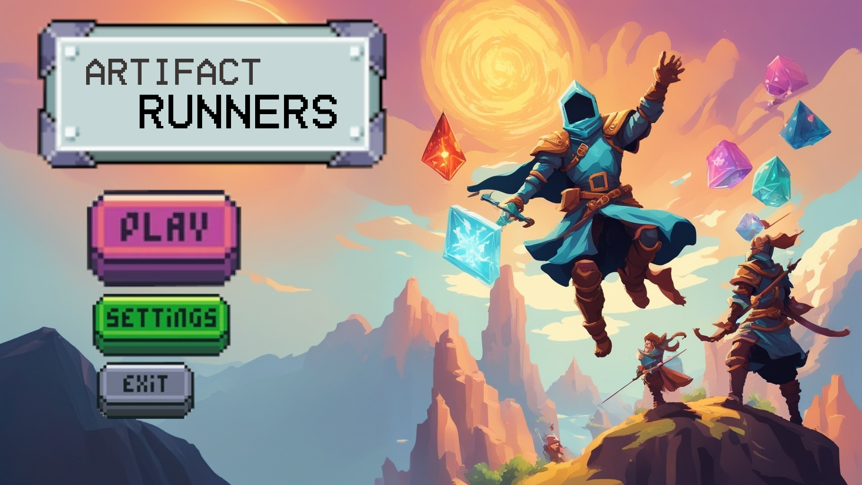

Mode Select(after pressing play button):

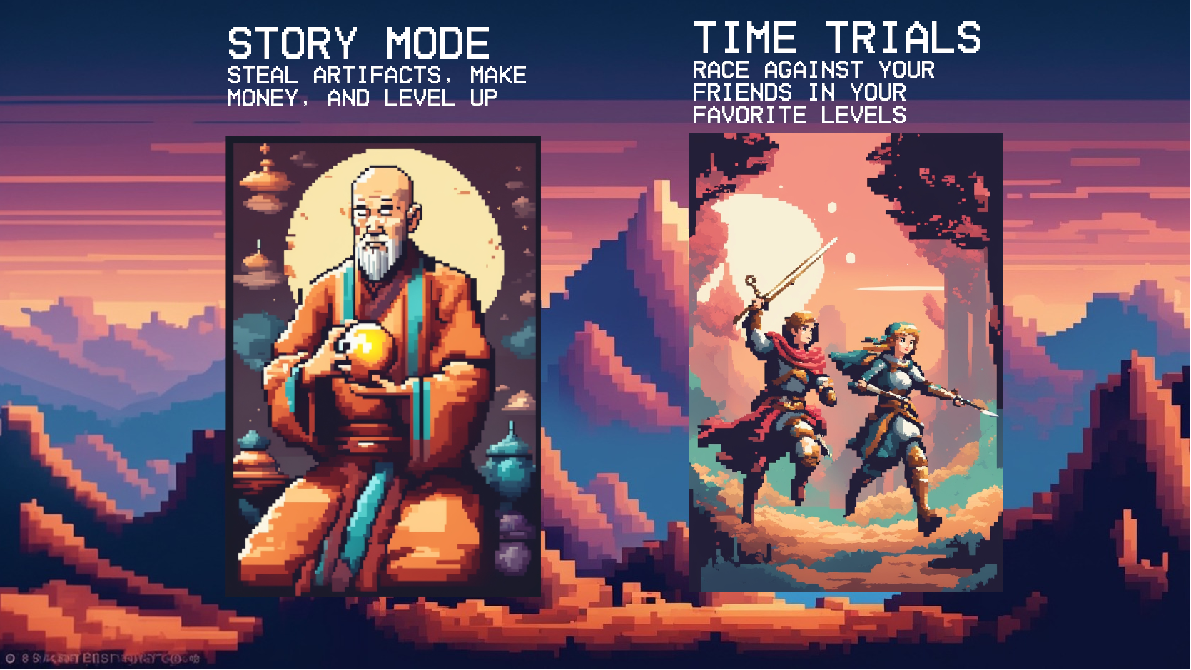

Level Select

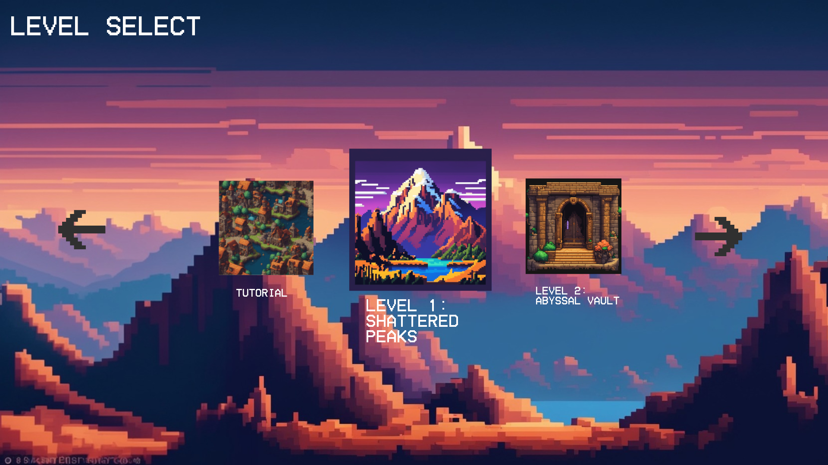

Load Screen:

Characters:

* Sir Dorian Woflbane (playable knight) - After failing to complete a mission for the royal guard he is banished and seeks redemption. Sir Dorian will be the first character implemented in our game. He will be a heavyweight character using a short range sword for slashing enemies.
* Thailor Eryndor (playable archer) - After a hunting expedition goes wrong Thailor shoots a sacred creature and is banished, labeled a heathen. She is a lightweight character with a bow and arrow for fighting enemies from a distance.
* Zephyros Calyndor (playable warlock) - When his mother, the only person he had left was dying, Zephyros made a pact with a powerful deity to save her but at the price of her completely forgetting she ever gave birth to him. Medium weight character with a medium range siphon attack that will lock onto enemies, slowly killing them.
* Lyra Dimir(playable rogue) - Lyra has only ever experienced betrayal in her life whether that be loved ones or fellow party members. She decides it’s time to leave the thieves guild to work with a group that will appreciate her skills. Lightweight character with a close range dagger attack and a dash that does slashing damage.
* Master Kray Ling (NPC Artificer) - Mentor for the players that will teach them about basic game movement and other tips. Master Ling will be the driving force in giving the players missions to complete and gear to use. Though he enjoys getting to know the characters he is secretly building an arcane nullifier to dominate by eradicating magic, making him the sole controller of all advanced technology. The players will have to come together to defeat him in a grand final boss battle without any magic or artifacts.

Plot:

This story begins in an adventurers guild where we meet our band of heroes. Each playable character explains their circumstances to each other and the 4 decide to party up for a job to get them back on their feet. One particular job seems to peak their interest. A flier is shown stating

“Hail, noble adventurers, travelers of distant lands and seekers of fortune! By decree of Master Kray Ling, esteemed head Artificer at The Galdwin academy of Arcane Engineering, a rare and ancient artifact has been lost in the depths of the Shattered Peaks, a treacherous mountain range where few dare to tread. This magical relic, vital to the invention of an artifact with unprecedented power, must be recovered at all costs! Interested parties should seek Master Kray Ling in the halls of Galdwin Academy in the heart of Eldhaven City. Riches await thee who dare take up this challenge.”

After taking the flier from the board the adventures head to Galdwin Academy. The party travels to Galdwin academy to speak with Master Ling where he gives them a quest to retrieve his Mox Opal and in return the players will gain an artifact of their choosing and 25 gold pieces each. Before they can go however Master Ling will test their skills with a simple tutorial level where the players will learn to run, jump, dash, as well as any other additions we add to gameplay in development.

Once finished with the tutorial the first level is unlocked and players will have to navigate treacherous mountains to find the camp of thieves that stole Master Ling’s special gem. Each arc will follow this pattern bringing the players to new towns and dungeons to unlock gear, until the final arc where the player will have to bring Master Ling’s plan to a halt.